**Mail Merge**

**To use Mail Merge:**

1. Open an **existing** Word document, or create a **new** one.
2. From the **Mailings** tab, click the **Start Mail Merge** command and select **Step-by-Step Mail Merge Wizard** from the drop-down menu.

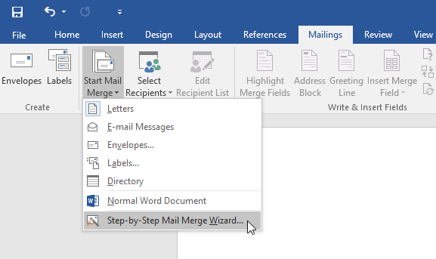

The Mail Merge pane will appear and guide you through the **six main steps** to complete a merge. The following example demonstrates how to create a form letter and merge the letter with a **recipient list**.

Step 1:

* From the Mail Merge task pane on the right side of the Word window, choose the **type** of document you want to create. In our example, we'll select **Letters**. Then click **Next: Starting document** to move to Step 2.

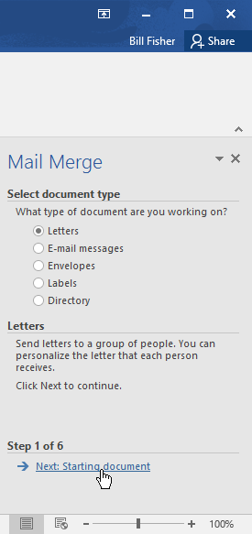

Step 2:

* Select **Use the current document**, then click **Next: Select recipients** to move to Step 3.



Step 3:

* Now you'll need an address list so Word can automatically place each address into the document. The list can be in an existing file, such as an **Excel workbook**, or you can **type a new address list** from within the Mail Merge Wizard.
  1. 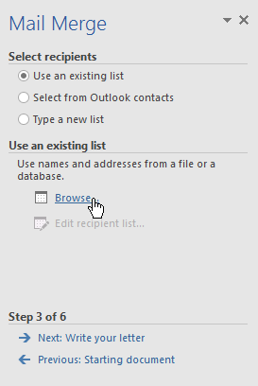Select **Use an existing list**, then click **Browse** to select the file.

1. Locate your file, then click **Open**.

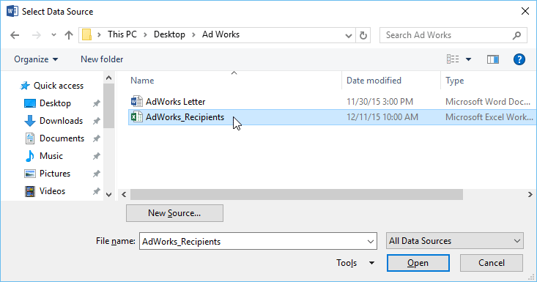

1. If the address list is in an Excel workbook, select the **worksheet** that contains the list, then click **OK**.

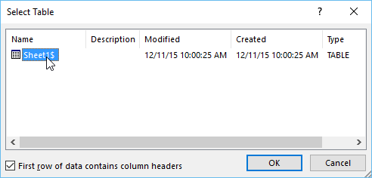

1. In the **Mail Merge Recipients** dialog box, you can **check** or **uncheck** each box to control which recipients are included in the merge. By default, all recipients should be selected. When you're done, click **OK**.

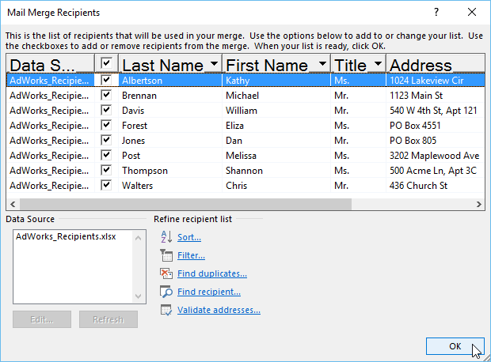

1. Click **Next: Write your letter** to move to Step 4.

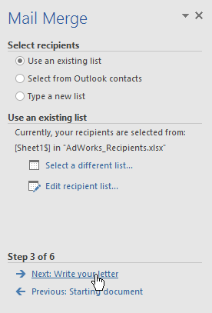

Step 4:

Now you're ready to write your letter. When it's printed, each copy of the letter will basically be the same; only the **recipient data** (such as the **name** and **address**) will be different. You'll need to add **placeholders** for the recipient data so Mail Merge knows exactly where to add the data.

* To insert recipient data:

1. Place the insertion point in the document where you want the information to appear.

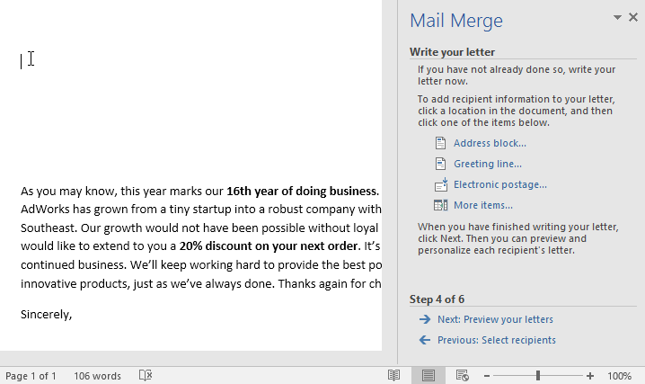

1. Choose one of the **placeholder** options. In our example, we'll select **Address block**.

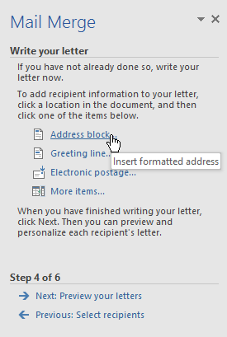

1. Depending on your selection, a dialog box may appear with various customization options. Select the desired options, then click **OK**

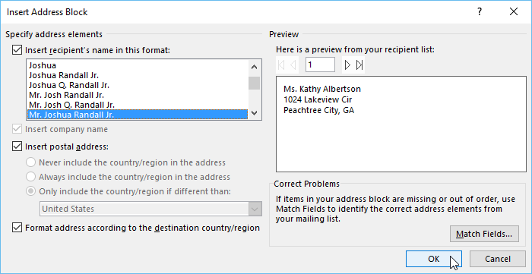

1. A placeholder will appear in your document (for example, **«AddressBlock»**).

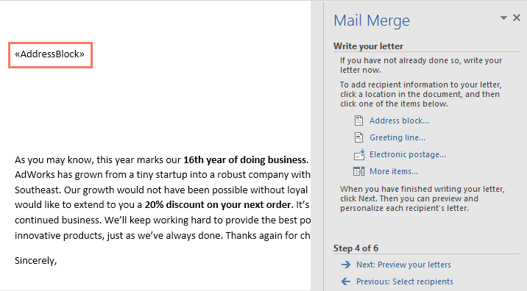

1. Add any other placeholders you want. In our example, we'll add a **Greeting line** placeholder just above the body of the letter.

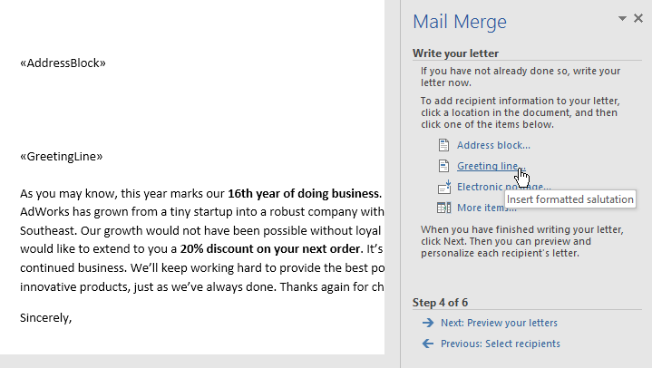

1. When you're done, click **Next: Preview your letters** to move to Step 5.

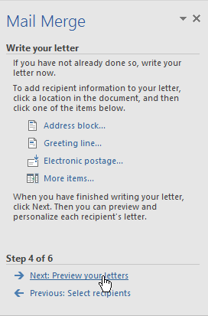

Step 5:

1. Preview the letters to make sure the information from the recipient list appears correctly in the letter. You can use the left and right scroll arrows to view each version of the document.

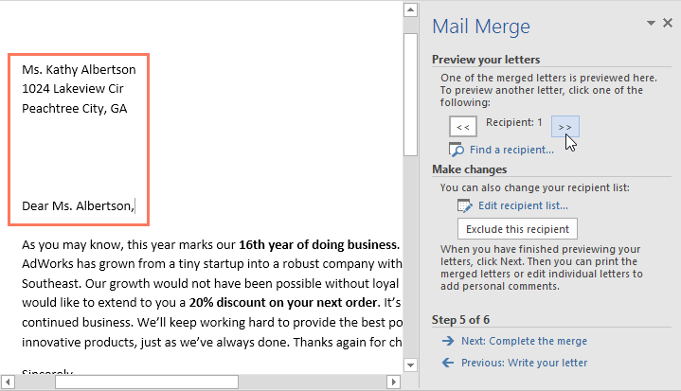

1. If everything looks correct, click **Next: Complete the merge** to move to Step 6.

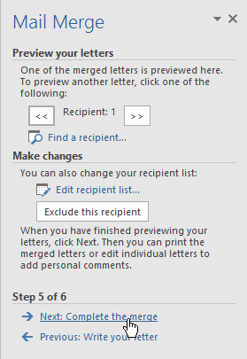

Step 6:

1. Click **Print** to print the letters.

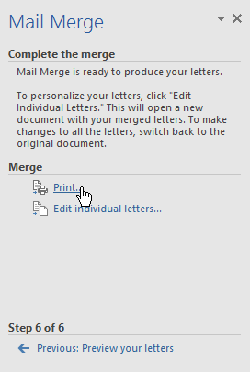

1. A dialog box will appear. Decide if you want to print **All** of the letters, the current document (record), or only a select group, then click **OK**. In our example, we'll print all of the letters.

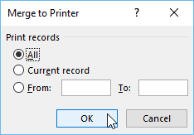

1. The **Print** dialog box will appear. Adjust the print settings if needed, then click **OK**. The letters will be printed.

